Surya Dinata

D&K Books  NSW 2000, Australia

Business evaluation



|  |  |  |  |
| --- | --- | --- | --- |
| Name of Student | Surya Dinata | ID | 18620 |

**Assessment – Research and Questioning**

Contents

Instructions: 1

Business Scenario 1

Task 1: Determine support areas 2

Task 2: Identify stakeholders 2

Task 3: Develop support procedures 2

Task 4: Assign Support Personnel 2

Task 5: Short Answer Questions 3

Task 6: Multiple Choice Questions 3

Search Index 8

# Instructions:

This is an individual assessment. Answer all the questions on the document provided by your Trainer.

***Duration:***

Trainer will set the duration of the assessment.

My Website URL : <https://exclusions1.github.io/Evaluation-Business/>

# Business Scenario

D&K Books Pty Ltd is a bookstore owned by Mr. Dean Kerr. The business occupies two levels of an office building connected by escalators and lifts. D&K Books employs approximately six sales staff, one operation manager, two administrative officers, a bookkeeper and a marketing manager. They have an Ethernet network consisting of ten PCs (Intel I3 Desktop cloned), two switches, a router and three printers. They use the QuickBooks software to manage their entire business, including sales, inventory, ordering, accounts receivable, accounts payable, payroll and employee management. They also have two EFTPOS terminals one on each floor.

D&K Books has a Linux server that stores all of the data including the QuickBooks database. The server is backed up to tape regularly. They also have a website (hosted on an Australian ISP’s server, dynamic and static pages using asp.net) on which customers can browse the product catalogue and view current specials. They also lease a telephone system from Live Telecoms. The PABX (phone system) consists of a main switchboard and five remote phones with three incoming lines and a message-on-hold queue system.

# Task 1: Determine support areas

Identify information technology (HW and SW) and list the technology in use in D&K Books and consider the following:

* What sort of support does the technology require?
* Who is likely to provide this support?
* Does the support arrangement already exist?

Present your answer in a table such as the one below:

|  |  |  |  |  |
| --- | --- | --- | --- | --- |
| **Technology** | **Description** | **Support Required** | **Provider** | **Support Already exists? (Yes/No)** |
| QuickBooks Software | A Software used by D&K Books to manage their business (sales, inventory, ordering, receivable account, payable account, payroll, and employee management) | It required a machine capable of running the software and also a storage big enough to store all data | Mr. Dean Kerr | Yes |
| PC’s | ten PCs (Intel I3 Desktop cloned) | Required basic component (motherboard, cpu, ram, ssd/hdd, monitor, mouse, keyboard) | Mr. Dean Kerr | Yes |
| Server | Linux server | Required basic component (motherboard,cpu,storage) | Mr. Dean Kerr | Yes |
| EFTPOS | two EFTPOS terminals one on each floor |  | Mr. Dean Kerr | Yes |
| Telephone system | a telephone system from Live Telecoms | Office number and also provider for the phone | Mr. Dean Kerr | Yes |
| Website | a website (hosted on an Australian ISP’s server, dynamic and static pages using asp.net) on which customers can browse the product catalogue and view current specials | Server, Database, and Program | Mr. Dean Kerr | Yes |

# Task 2: Identify stakeholders

Identify stakeholders related in D&K Books system

A stakeholder is either an individual, group or organization that’s impacted by the outcome of a project or a business venture. Stakeholders have an interest in the success of the project and can be within or outside the organization that’s sponsoring the project. Stakeholders are important because they can have a positive or negative influence on the project with their decisions. There are also critical or key stakeholders, whose support is needed for the project to exist.

So, in D&K Books ,Everyone including sales staff, operation manager, administrative officers, book keeper, marketing manager.

# Task 3: Develop support procedures

1. Describe one positive and one negative experience you have had when seeking assistance from a telecommunications company, an ISP or a computer supplier. Your experience may be via telephone, email or even voice recognition.

I once had problem with my wifi router which indicated with red blink on los, so I contacted the provider by using phone call. It was very easy but hard to find the exact phone number for our area of service which was different for every area. After the call connected I just need to let them know what is the problem and then the customer service will assign a mechanic to go into our house to fix the router. In a few hours after call ended the mechanic arrived and in about one hour the problem was fixed.

1. Using the experiences described above please answer the following questions.
   1. What support aspects were professional and/or unprofessional?

the customer service was very helpful but the only problem is that phone number used by every are of service is different so it may take some time to find the correct number.

* 1. How long did the support process take?

For the call to go through just took a few second to connect and for the repair it was about an hour, as the mechanic has to check the cable connected to electric pole.

* 1. Were the steps logical?

First he checked if the cable is bend or scratched open or cut. Then after that he checked the router by lan cable to see if the router connected fine to the internet. Then after a few settings the los blink has gone then after a restart it was just fine.

* 1. Did they solve your problem?

Yes they solved it pretty quick.

* 1. Was the call deflected to another area?

No it wasn’t because we called the correct number.

# Task 4: Assign Support Personnel

Classify the following into soft skills and technical skills. Your answer should take the form of a table shown below.

|  |  |  |
| --- | --- | --- |
| **Skill** | **Soft skill** | **Technical skill** |
| A knowledge of Linux |  | T because it has to be learned to have the knowledge |
| The ability to work under pressure | T a soft skill because it could be possessed without practiced |  |
| The administration of Windows 2008 Server |  | T it has to be learned |
| The ability to formulate network and IT policies |  | T it has to be learned |
| The ability to write network documentation |  | T it has to be learned |
| The ability to give presentations | T It is a soft skill because it depend on someone social and speaking skill |  |
|  | | |

# Task 5: Short Answer Questions

1. Explain the relationship between data, information and knowledge.

Data is fragmented pieces of symbols and characters strung together, information is refined data whereas knowledge is useful information. Additionally, data can lack context when looked at singularly, whereas information gives context to data and knowledge brings depth in understanding to such information.

1. What is quantitative data and how can you use it.

Quantitative data are data represented numerically, including anything that can be counted, measured, or given a numerical value.

Quantitative data is data that can be counted or measured in numerical values. The two main types of quantitative data are discrete data and continuous data. Height in feet, age in years, and weight in pounds are examples of quantitative data.

1. What is qualitative data and how can you use it.

Qualitative data is information that cannot be counted, measured or easily expressed using numbers. It is collected from text, audio and images and shared through data visualization tools, such as word clouds, timelines, graph databases, concept maps and infographics.

Qualitative data describes qualities or characteristics. It is collected using questionnaires, interviews, or observation, and frequently appears in narrative form. For example, it could be notes taken during a focus group on the quality of the food at Cafe Mac, or responses from an open-ended questionnaire.

1. Give an example of how quantitative and qualitative data can be used in conjunction with each other

For example, a study on healthcare quality might use surveys to collect quantitative data on patient satisfaction, and interviews to collect qualitative data on patient experiences. The data are analyzed separately and then integrated into the interpretation stage.

a closed-ended questionnaire to many service users is done at the same time as semi-structured observations of the service center. Sequencing is one way of combining qualitative and quantitative data by alternating between them.

1. What sort of methods could you use to determine client requirements for a website design and key information sources?

The requirement could be gathered by surveing the clients of what they needed in the web and what is the purpose of the website.

1. Give some examples of client requirements for a website design

For example, the requirement could be Font, Color, Background, functions, and how will they reach the customer? Is it by email or phone number?

# Task 6: Multiple Choice Questions

1. Generally, how many points should a rating scale have?
   1. Five
   2. Four
   3. Ten
   4. Somewhere from 4 to 11 points

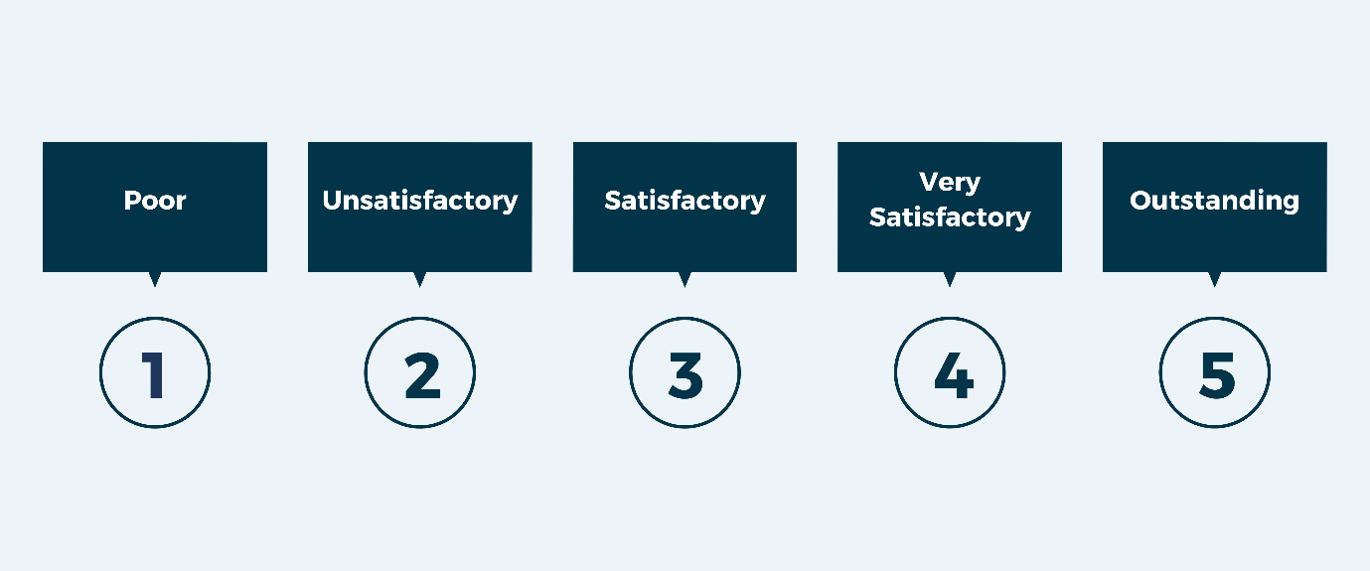

1. What is the problem(s) with this set of response categories to the question “What is your current age?” o 1-5 o 5-10 o 10-20 o 20-30 o 30-40
   1. The categories are not mutually exclusive
   2. The categories are not exhaustive
   3. Both a and b are problems
   4. There is no problem with the above set of response categories

First, there are two repetitive number which might confuse people. Second, it doesn’t cover all ages human could have.

1. You should mix methods in a way that provides complementary strengths and no overlapping weaknesses. This is known as the fundamental principle of mixed research.

a) True

b) False

Because to do a research there will be a strength and weakness for method used so in order to determine which method the best, you will need to compare strength and weakness of every method used.

1. According to the text, questionnaires can address events and characteristics taking place when?
   1. In the past (retrospective questions)
   2. In the present (current time questions)
   3. In the future (prospective questions)
   4. All of the above

1. Which of the following are principles of questionnaire construction?
   1. Consider using multiple methods when measuring abstract constructs
   2. Use multiple items to measure abstract constructs
   3. Avoid double-barrelled questions
   4. All of the above
   5. Only b and c

We should avoid double meaning questions because it will become ambiguous to customer that they either answer yes or no.

1. Which of these is not a method of data collection?
   1. Questionnaires
   2. Interviews
   3. Experiments
   4. Observations

Experiments is something you do when researching.

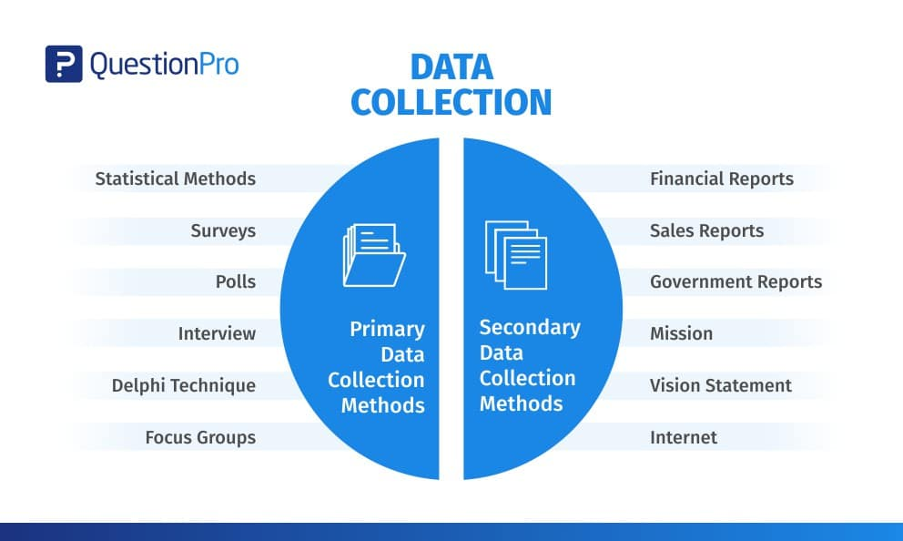

1. Secondary/existing data may include which of the following?
   1. Official documents
   2. Personal documents
   3. Archived research data
   4. All of the above

Secondary data means data collected by someone else earlier.

1. An item that directs participants to different follow-up questions depending on their response is called a ____________.
   1. Response set
   2. Probe
   3. Semantic differential
   4. Contingency question

Contingency questions are questions that are only to be answered by some subgroup(s) of respondents. For example, "If you own your home, how long have you owned it?" Contingency questions may have either closed-ended or open-ended response options.

1. Which of the following terms best describes data that were originally collected at an earlier time by a different person for a different purpose?

a) Primary data

* 1. Secondary data
  2. Experimental data
  3. Field notes

Secondary data means data collected by someone else earlier.

1. Researchers use both open-ended and closed-ended questions to collect data. Which of the following statements is true?
   1. Open-ended questions directly provide quantitative data based on the researcher’s predetermined response categories
   2. Closed-ended questions provide quantitative data in the participant’s own words
   3. Open-ended questions provide qualitative data in the participant’s own words
   4. Closed-ended questions directly provide qualitative data in the participants’ own words

Close-ended questions are commonly used in surveys because they enable survey creators to collect quantitative data that can then be tallied into scores, percentages, or statistics that are tracked over time.

If you’re conducting a survey, you’re interested in hearing about your individual respondents’ opinions and experiences. A lot of this important information can be collected through multiple choice questions or drop-down questions, in which respondents select the response that most closely aligns with their own from a set of options.

These questions are great when you want to collect qualitative or quantitative data that you can aggregate and analyze, like when you’re tallying the percentage of your respondents who are men and women or who fall in different age ranges.

1. Open-ended questions provide primarily ______ data.
   1. Confirmatory data
   2. Qualitative data
   3. Predictive data
   4. None of the above

Open ended questions are ideal for qualitative research, as they allow researchers to probe much deeper into a respondent's answers. This can enable them to gain valuable information about a subject that they might not otherwise pick up.

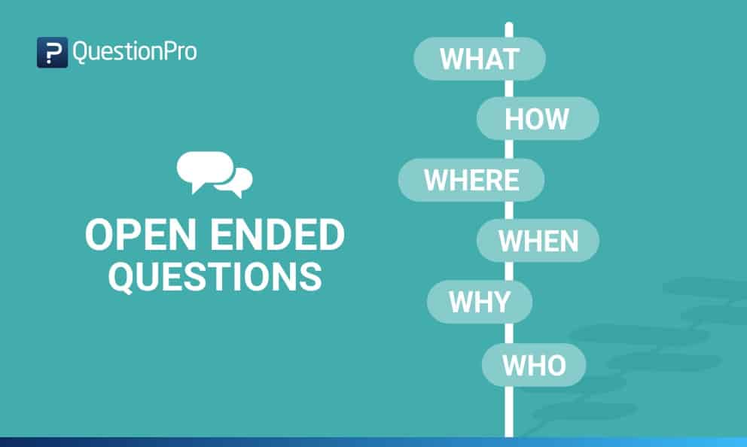

1. Which of the following is true concerning observation?
   1. It takes less time than self-report approaches
   2. It costs less money than self-report approaches
   3. It is often not possible to determine exactly why the people behave as they do
   4. All of the above

1. Qualitative observation is usually done for exploratory purposes; it is also called ___________ observation.
   1. Structured
   2. Naturalistic
   3. Complete
   4. Probed

Naturalistic observation is a qualitative research method where you record the behaviors of your research subjects in real world settings. You avoid interfering with or influencing any variables in a naturalistic observation. You can think of naturalistic observation as “people watching” with a purpose.

1. When constructing a questionnaire, it is important to do each of the following except ______.
   1. Use "leading" or "loaded" questions
   2. Use natural language
   3. Understand your research participants
   4. Pilot your test questionnaire

Leading and loaded questions have small differences, but it’s important to remember that they are both ways to confuse, mislead, or influence users into making a particular selection.

Sometimes they’re created deliberately, other times they’re unintentional. In nearly all cases, it’s possible to modify both leading and loaded questions to present better options to users and get more accurate results in return.

1. Another name for a Likert Scale is a(n):
   1. Interview protocol
   2. Event sampling
   3. Summated rating scale
   4. Ranking

Likert scales are often called summative scales. <https://en.wikipedia.org/wiki/Likert_scale#:~:text=Hence%2C%20Likert%20scales%20are%20often,are%20the%20most%20applicable%20methods>.

1. Which of the following is not one of the six major methods of data collection that are used by educational researchers?
   1. Observation
   2. Interviews
   3. Questionnaires
   4. Checklists

Six Major data colletion method are observation, interviews, questionnaire, case study, projective technique, schedule.

1. The type of interview in which the specific topics are decided in advance but the sequence and wording can be modified during the interview is called:

a) The interview guide approach

* 1. The informal conversational interview
  2. A closed quantitative interview
  3. The standardized open-ended interview

1. Which one of the following in not a major method of data collection?
   1. Questionnaires
   2. Interviews
   3. Secondary data
   4. Focus groups
   5. All of the above are methods of data collection

Six Major data colletion method are observation, interviews, questionnaire, case study, projective technique, schedule.

1. A question during an interview such as “Why do you feel that way?” is known as

a) Probe

* 1. Filter question
  2. Response
  3. Pilot

The definition of a probing question is: “A question that you ask to gain greater insight into what someone has just told you, helping you to dig a little deeper, as well as uncover the reasons and emotions behind what they have said.

1. A census taker often collects data through which of the following?
   1. Standardized tests
   2. Interviews
   3. Secondary data
   4. Observations

A Census takers often collect data through interviews.

<https://www.chegg.com/homework-help/questions-and-answers/q11-census-taker-often-collects-data-following--standardized-tests-b-interviews-c-secondar-q85410225>

1. The researcher has secretly placed him or herself (as a member) in the group that is being studied. This researcher may be which of the following?

a) A complete participant

* 1. An observer-as-participant
  2. A participant-as-observer
  3. None of the above

Because he/her has placed her self as s member of the group which they joined.

1. Which of the following is not a major method of data collection?
   1. Questionnaires
   2. Focus groups
   3. Correlational method
   4. Secondary data

1. Which type of interview allows the questions to emerge from the immediate context or course of things?

a) Interview guide approach

* 1. Informal conversational interview
  2. Closed quantitative interview
  3. Standardized open-ended interview

Informal Conversational Interview: This type of interview may occur spontaneously in the course of field work, and the respondent may not know that an "interview" is taking place. Questions emerge from the immediate context, so the wording of questions and even the topics are not predetermined.

1. When conducting an interview, asking "Anything else? What do you mean? Why do you feel that way?," etc, are all forms of:
   1. Contingency questions
   2. Probes
   3. Protocols
   4. Response categories

The definition of a probing question is: “A question that you ask to gain greater insight into what someone has just told you, helping you to dig a little deeper, as well as uncover the reasons and emotions behind what they have said.

1. When constructing a questionnaire, there are 15 principles to which you should adhere. Which of the following is not one of those principles?
   1. Do not use "leading" or "loaded" questions
   2. Avoid double-barrelled questions
   3. Avoid double negatives
   4. Avoid using multiple items to measure a single construct

The correct one is avoid using multiple items to measure lots of construct

1. A customer-based Service Level Agreement structure includes:
   1. An SLA covering all Customer groups and all the services they use
   2. SLAs for each service that are Customer-focused and written in business language
   3. An SLA for each service type, covering all those Customer groups that use that Service
   4. An SLA with each individual Customer group, covering all of the services they use

As the name implies the service requirement should fulfill customer needs.

1. Which of the following best describes the goal of Service Level Management?
   1. To maintain and improve IT service quality in line with business requirements
   2. To provide IT services at the lowest possible cost by agreeing with Customers their minimum requirements for service availability and ensuring performance does not exceed these targets
   3. To provide the highest possible level of service to Customers and continuously improve on this through ensuring all services operate at maximum availability
   4. To ensure that IT delivers the same standard of service at the least cost

Project is done by following the requirement requested by clients

1. The process to implement SLAs comprises of the following activities in sequence:
   1. Draft SLAs, catalogue services, review underpinning contracts and OLAs, draft SLRs, negotiate, agree

SLAs

* 1. Draft SLAs, review underpinning contracts and OLAs, negotiate, catalogue services,
  2. Review underpinning contracts and OLAs, draft SLAs, catalogue services, negotiate, agree SLAs
  3. Catalogue services, establish SLRs, review underpinning contracts and OLAs, negotiate service levels, agree SLAs

1. Which of the following is an example of a service level agreement (SLA) between an information systems support unit and a research unit in the laboratories of a large company?
   1. The maximum response time to get the system operational should it fail.
   2. The minimum ‘up-time’.
   3. The types of information that will be provided as standard.
   4. All of the above.

1. Some organisations bring a degree of formality to the internal customer concept by encouraging (or requiring) different parts of the operation to agree on:

a) Internal service agreements

* 1. Service level agreements
  2. Formal provision agreements
  3. Delivery agreements

# Search Index

Task 1: Determine support areas

Task_2:_Identify

Task 3: Develop support procedures

Task 4: Assign Support Personnel

Task 5: Short Answer Questions

Task 6: Multiple Choice Questions